Instructions:

* The midterm is an open book exam
* The instructor cannot assist on the midterm
* The exam must be turned in before class

Good luck.

**There are 8 print screens each is worth 12.5%**

**Project #1 (based on Chapter 5 functions) for the program below be sure to use functions.**

**#1 Print screen the output with the code below here.**

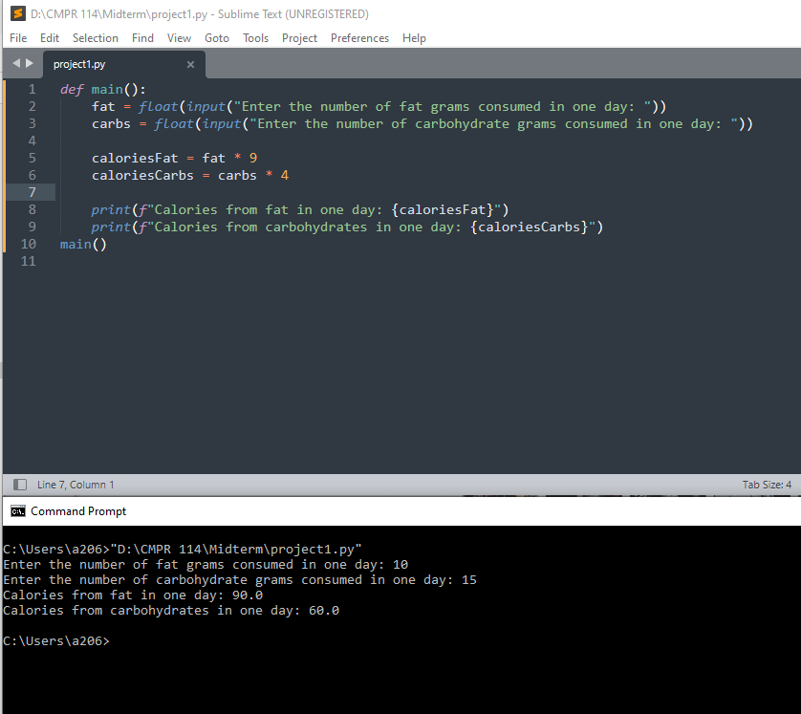

**Project #2 (based on Chapter 6 Files and Exceptions)**

Write a program that will **read** the coffee text file (please download from module 8 midterm). Display the entire file on the console.

**#2 Print screen the output with the code below here.**

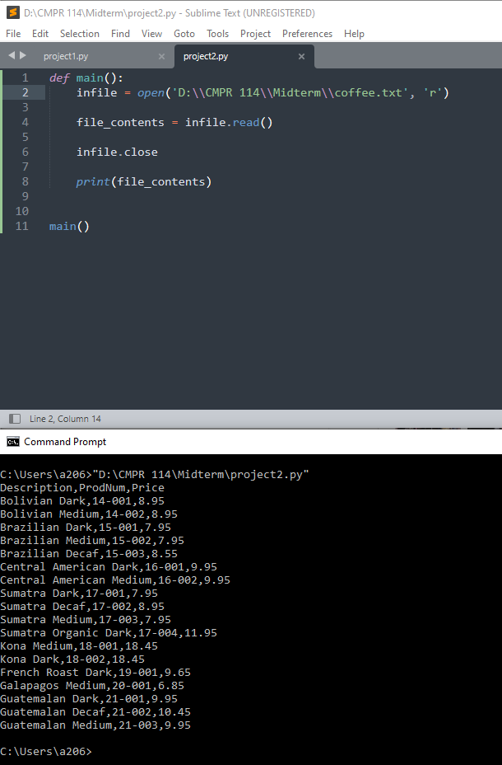

Write a program that will **write** to the coffee text file, enter your favorite coffee brand, with the prod number 21-003, and price 10.32.

**#3 Print screen the output with the code below here.**

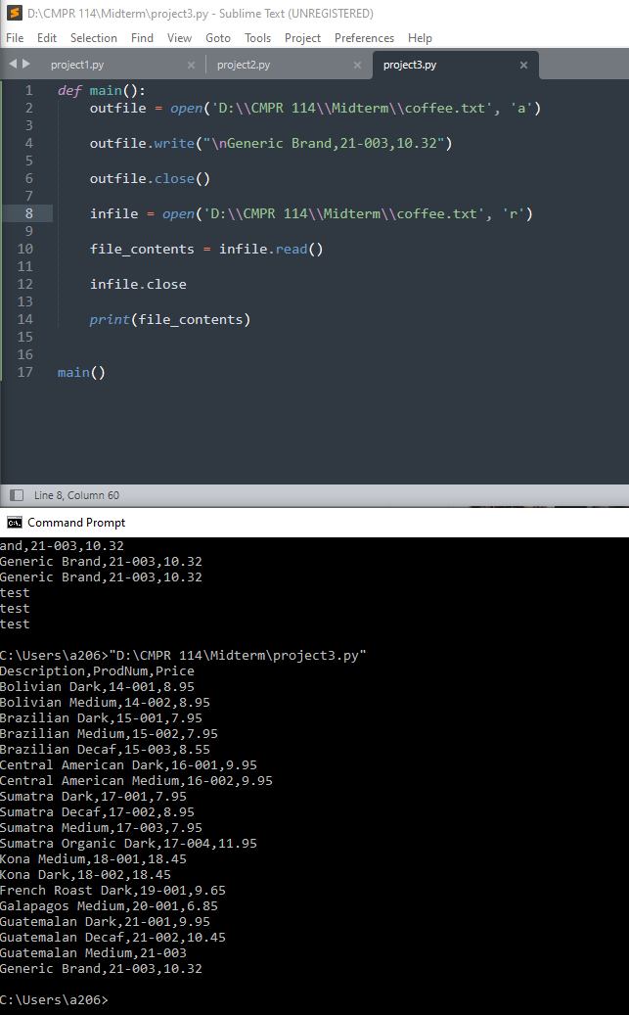

Create a text file that contains your expenses for last month in the following categories: The program will have the ability to write and read from the text file. You may create and or format text file anyway you wish.

• Rent

• Gas

• Food

• Clothing

• Car payment

**#4 Print screen the output with the code below here.**

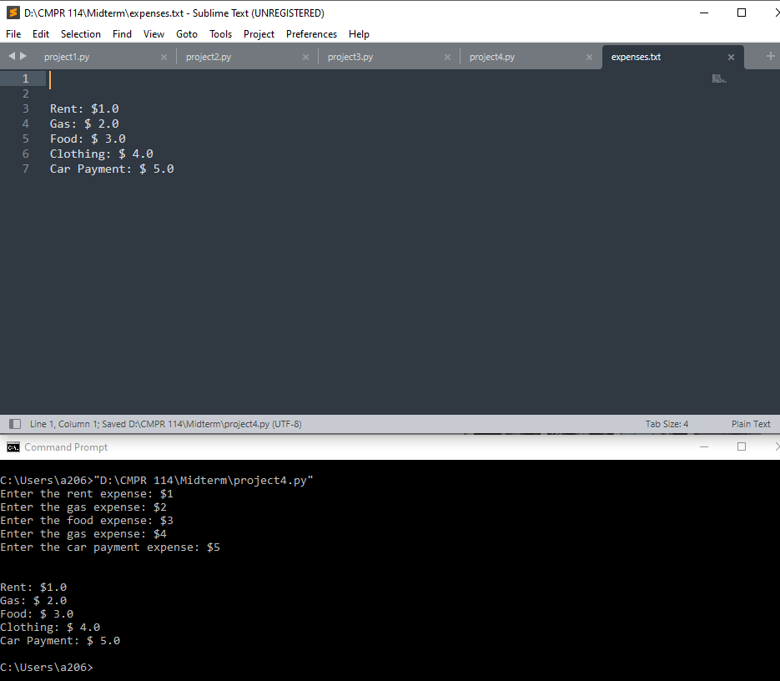

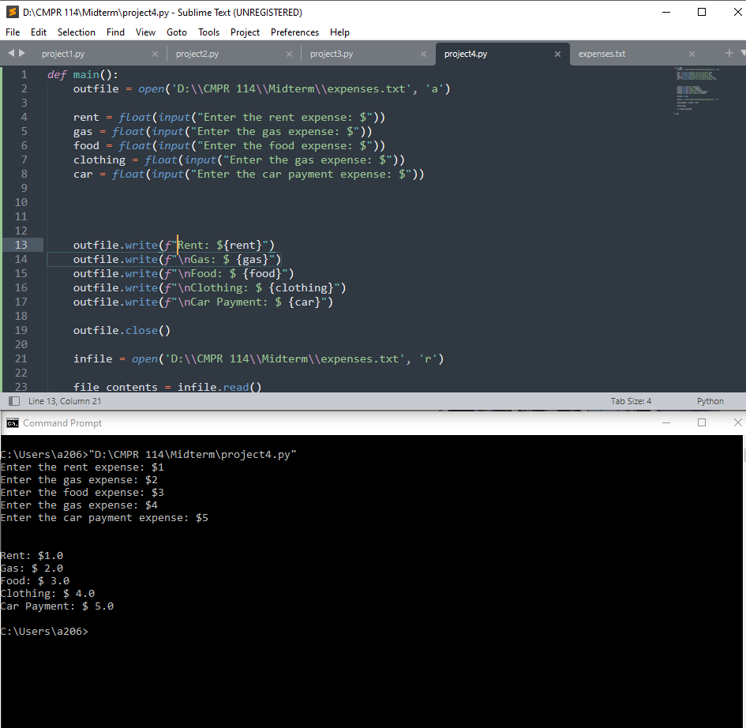

This program will ask the user to enter 5 names and their ages, and

**Project #3 (based on Chapter 7 Lists and Tuples)**

Create a 1-D list with the numbers 1-10 and get the sum and average of the numbers.

**#5 Print screen the output with the code below here.**

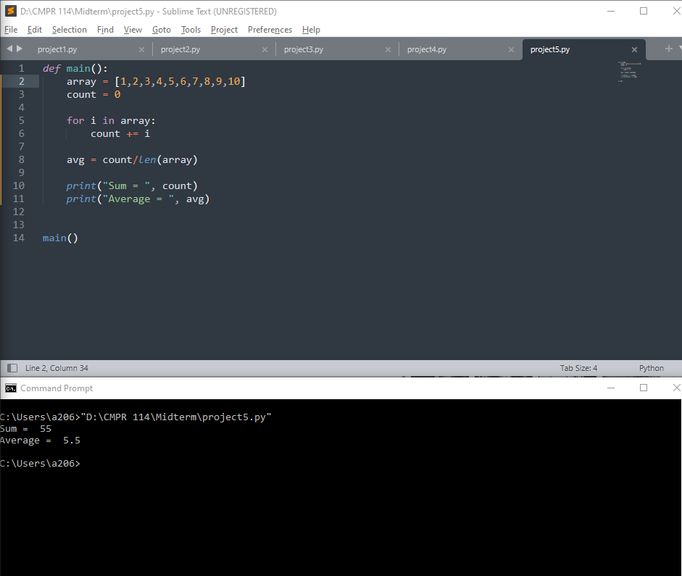

In the 1-D list retrieve only the lucky number 7.

**#6 Print screen the output with the code below here.**

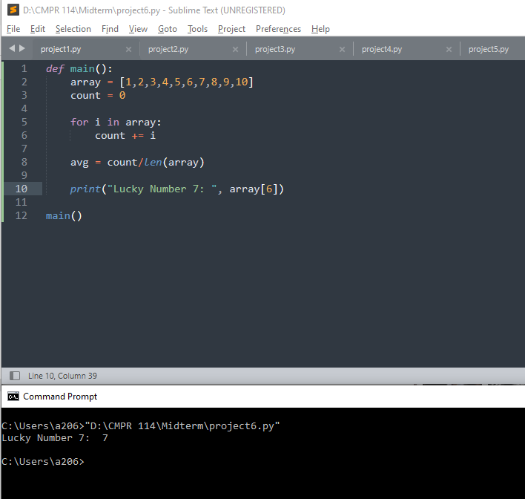

Create a 2-D list with the numbers 1-10 and retrieve the lucky number 7. Below is an example of a 2-d list.

**#7 Print screen the output with the code below here.**

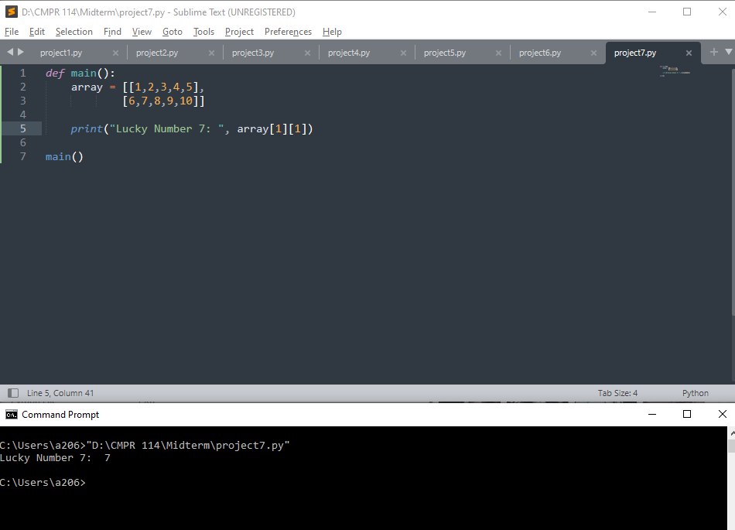

Create a list of 5 random names and using a for loop print the names in console.

**#8 Print screen the output with the code below here.**

